**Methane – Carbon Dioxide Interaction: A Classical Molecular Dynamics Simulation Study**

***thesis submitted in the partial fulfilment for the award of the degree of***

***Master of Science***

***in***

***Applied Geology***

***by***

**Subrata Haldar**

**(18GG5PE02)**

**Under the supervision of**

**Dr. M. K. Panigrahi**



**Department of Geology and Geophysics**

**Indian Institute of Technology Kharagpur**

**May 2023**

**Declaration**

I certify that:

1. I have done the work contained in this report under the guidance of my supervisor.
2. The work has not been submitted to any other Institute for any degree or diploma.
3. I have conformed to the norms and guidelines given in the Ethical Code of Conduct of the Institute.
4. Whenever I have used materials (data, theoretical analysis, figures, and text) from other sources, I have given due credit to them by citing them in the text of the thesis and providing their details in the references. Further, I have taken permission from the copyright owners of the sources whenever necessary.

Date: May 03, 2023

Place: IIT Kharagpur

(Subrata Haldar)

**Certificate**

This is to certify that the project report entitled **“Methane – Carbon Dioxide Interaction: A Classical Molecular Dynamics Study”** submitted by Subrata Haldar (Roll No. 18GG5PE02) to the Indian Institute of Technology Kharagpur towards partial fulfilment of requirements for the award of the degree of **M.Sc. in Applied Geology** is a record of bona fide work carried out by him under my supervision and guidance during Spring Semester, 2022-23.

(S. P. Sharma)

Head of Department, Geology & Geophysics

(M. K. Panigrahi)

Faculty of Sciences, Geology & Geophysics

**Abstract**

Methane and carbon dioxide are an integral part of several critical geological processes. They are closely tied to the greenhouse effect, hydrocarbon formation, and other processes that significantly impact our lives. This work visualised a methane and carbon dioxide system using Classical Molecular Dynamics across different PT conditions. The aim was to determine if there is any interaction between CH4 and CO2 molecules at these PT conditions or if there’s any clustering or patterns formation in their fluid mixture. OPLS-AA (Optimized Potentials for Liquid Simulations All Atom) by Jorgensen se al. was used to simulate varying mole fractions of CH4 and CO2 fluids. The simulation results were then validated using RDF and expected density data (at simulated PT conditions). These simulations were carried out in order to replicate conditions which may arise during the subsurface storage of above gases.

**Acknowledgements**

First and foremost, I would like to thank my supervisor Dr. M. K. Panigrahi. This thesis would not have been accomplished without his assistance and dedicated involvement in every step of the process. I am grateful for his support and understanding over the past year.

I would also like to express my thanks to Mr. R. Mohanta. He has been there to help me with any issues I’ve faced while performing my simulation, and his input has greatly helped me throughout the process.

Finally, I would like to thank all the officials of the High-Performance Computing Facility (HPC), IIT Kharagpur for providing the necessary computational facilities required for this project.

**Table of Contents**

**List of figures** 7

**List of tables** 8

**Chapter I: Introduction** 9

**1.1 Background of the Problem** 9

**1.2 Statement of the Problem** 9

**1.3 Purpose of the Study** 9

**1.4 Research Questions** 9

**1.5 Significance of the Study** 10

**1.6 Definition of Terms** 10

**1.7 Assumptions, Limitations and Delimitations** 11

**Chapter II: Methodology** 12

**2.1 Research Design** 12

**2.1.1 Introduction** 12

**2.1.2 Simulation Conditions and Interaction Potentials** 13

**2.2 Data Analysis** 16

**Chapter III: Results** 18

**3.1 Findings** 18

**3.2 Summary** 29

**Chapter IV: Discussion** 30

**4.1 Conclusions** 30

**4.2 Discussion** 30

**4.3 Suggestions for Future Research** 30

**References** 31

**Appendices** 32

**Appendix A – Packmol Code** 32

**Appendix B – LAMMPS Molecular DATA** 33

**Appendix C – LAMMPS Simulation Code** 39

# **List of figures**

**Figure 2.1:CH4 molecule created using Avogadro ………….**…………………..…………………………………. 12

**Figure 2.2: CO2 Molecule created using Avogadro** ……………………………..…………………………………. 12

**Figure 2.3: Unequilibrated CO2 – CH4 mixture (XCH4 = 0.1)** …………………..…………………………………. 14

**Figure 2.4: Equilibrated CO2 – CH4 mixture (XCH4 = 0.1)** …………………………………………..……………… 15

**Figure 2.5: Calculation of RDF g(r)** …………………………………………………………………….……………………. 16

**Figure 3.1: C (sp3) – C (sp3) RDF (P = 5000 atm, T = 1000 K, XCH4 = 0.1)** …………….……………………. 20

**Figure 3.2: C (sp3) – H RDF (P = 5000 atm, T = 1000 K, XCH4 = 0.1)** ….…..…………….………………….… 20

**Figure 3.3: C (sp3) – C (sp) RDF (P = 5000 atm, T = 1000 K, XCH4 = 0.1)** ….………………………………… 21

**Figure 3.4: C (sp3) – O RDF (P = 5000 atm, T = 1000 K, XCH4 = 0.1)** ………………………….….…………… 21

**Figure 3.5: H – H RDF (P = 5000 atm, T = 1000 K, XCH4 = 0.1)** ………………….…………………..…………… 22

**Figure 3.6: H – C (sp) RDF (P = 5000 atm, T = 1000 K, XCH4 = 0.1)** ………………………..…………………… 22

**Figure 3.7: H – O RDF (P = 5000 atm, T = 1000 K, XCH4 = 0.1)** …………………….….………………….……… 23

**Figure 3.8: C (sp) – C (sp) RDF (P = 5000 atm, T = 1000 K, XCH4 = 0.1)** ……….….………………….……… 23

**Figure 3.9: C (sp) – O RDF (P = 5000 atm, T = 1000 K, XCH4 = 0.1)** ………………….……………..….……… 24

**Figure 3.10: O – O RDF (P = 5000 atm, T = 1000 K, XCH4 = 0.1)** …..…………………………………….……… 24

**Figure 3.11: Simulation after 0 time steps (P = 5000 atm, T = 1000 K, XCH4 = 0.5) .…**…….…….… 25

**Figure 3.12: Simulation after 10000 time steps (P = 5000 atm, T = 1000 K, XCH4 = 0.5) …………** 25

**Figure 3.13: Simulation after 20000 time steps (P = 5000 atm, T = 1000 K, XCH4 = 0.5)** ……..…… 26

**Figure 3.14: Simulation after 40000 time steps (P = 5000 atm, T = 1000 K, XCH4 = 0.5)** …………… 26

**Figure 3.15: Simulation after 0 time steps (P = 1000 atm, T = 1000 K, XCH4 = 0.5)** ……….……..… 27

**Figure 3.16: Simulation after 10000 time steps (P = 1000 atm, T = 1000 K, XCH4 = 0.5)** ………..… 27

**Figure 3.17: Simulation after 20000 time steps (P = 1000 atm, T = 1000 K, XCH4 = 0.5)** ………..… 28

**Figure 3.18: Simulation after 40000 time steps (P = 1000 atm, T = 1000 K, XCH4 = 0.5) .**….……… 28

# **List of tables**

**Table 2.1: Parameters for OPLS-AA model of CO2 and CH4** …………………………………………………… 15

**Table 3.1: Comparison of simulated and expected density values** …………………………………..…… 18

# **Chapter I: Introduction**

## **1.1 Background of the Problem**

Methane and carbon dioxide are two of the most commonly seen greenhouse gases in the atmosphere. They have a significant contribution to the greenhouse effect (13-35%) (Kiehl and Trenberth, 1997) and are involved in a number of other geological processes such as hydrocarbon reservoir formation, marshland emissions, melting of glaciers, etc. While much is known about the two gases in general, the mechanisms governing the interaction of greenhouse gases at high PT (pressure-temperature) conditions is still under study. Understanding and visualising the interaction and transport of CO2 and CH4 molecules at high PT conditions (such as those present in the subsurface) will have several important applications in geosciences ranging from Reservoir Surveys to entrapment and storage of greenhouse gases in the subsurface.

## **1.2 Statement of the Problem**

In nature, CH4 and CO2 are gases which are immiscible with each other. Nevertheless, they are often found together in several different geological settings due to the process of their formation. Another important factor to note is that both gases are considered as greenhouse gases and thus contribute towards the overall climate change (global warming). CO2 and CH4 aren’t necessarily undesirable because while they lead to an increase in the average global temperature, they also have many other practical uses. One of the relatively newer fields of study related to this is the entrapment of greenhouse gases in the subsurface. To understand this, it is important to analyse the behavior of said gases at high PT conditions and also their interaction among themselves.

## **1.3 Purpose of the Study**

This work is a modest attempt to stimulate the interaction of the binary gas mixture of CO2 and CH4 to determine if there’s any miscibility or molecular interaction at high PT conditions. Since varying concentrations of CO2 and CH4 are available naturally depending on the environmental setting, different mole fractions of the two gases have been used for the simulations.

## **1.4 Research Questions**

The questions that this study attempts to answer are:

1. Is there any change to the immiscibility of CH4 and CO2 at high PT conditions?
2. Do the molecules of CH4 and CO2 interact with each other or show any signs of layering or clustering at these PT conditions?

## **1.5 Significance of the Study**

This study is important because it lays the foundation for more advanced research on the interaction of greenhouse gases at high PT conditions. The data obtained from it can be used to conduct further analysis to determine the most suitable methods of storing said gases like CH4 and CO2 in the subsurface, thus reducing the negative effect they have on the environment.

## **1.6 Definition of Terms**

**Greenhouse gas**: A gas that absorbs and emits radiant energy at thermal infrared wavelengths, causing the greenhouse effect.

**Greenhouse effect**: A process in which gases in Earth's atmosphere trap some of the heat radiated from the Sun, resulting in Earth being much warmer than without an atmosphere.

**Molecular Dynamics**: A computer simulation method for analysing the physical movements of atoms and molecules over a fixed period of time.

**Periodic Boundary Conditions (PBCs)**: A set of boundary conditions often chosen for approximating a large (infinite) system by using a small part called a unit cell.

**Isothermal**: A type of thermodynamic process in which the temperature of a system remains constant: ΔT = 0.

**Isobaric**: An isobaric process is a type of thermodynamic process in which the pressure of the system stays constant: ΔP = 0.

**Ensemble**: An idealisation consisting of many copies of a system, considered all at once, each of which represents a possible state that the real system might be in. Different statistical ensembles can be generated depending on which state variables (e.g., the energy E, volume V, temperature T, pressure P, and number of particles N) are kept fixed.

**Lennard-Jones Potential**: An intermolecular pair potential which describes the energy of interaction between two rare gas atoms as a function of the distance between their centres.

**Fast Fourier Transform algorithm**: An algorithm that computes an input's Discrete Fourier Transform (DFT) significantly faster than directly computing it. The Fourier Transform (FT) is a mathematical technique used to transform a function of time, x(t), to a function of frequency, X(ω).

**Poisson’s Equation**: A partial differential equation (PDE) which states that the Laplacian of the electric potential field is equal to the volume charge density divided by the permittivity, with a change of sign.

## **1.7 Assumptions, Limitations and Delimitations**

Some assumptions and/or limitations that were considered and/or faced during this study are:

1. No reaction force fields have been used to account for the formation of precipitate or other substances (if any) with the change in PT conditions.
2. The simulation box created for this study does not account for external forces acting on the binary gas mixture (if any).
3. Simulations were conducted only for high PT conditions, and cases of high pressure, but low temperature weren’t considered. This makes the results of this study only valid for the gaseous state of CH4 and CO2.

# **Chapter II: Methodology**

## **2.1 Research Design**

### **2.1.1 Introduction**

This study makes use of classical molecular dynamics creating a finite box with a periodic boundary and a fixed number of CO2 and CH4 molecules. The simulations have been carried out using an NPT ensemble (isothermal-isobaric ensemble or NPT ensemble is a statistical mechanical ensemble that maintains a constant number of particles (N), a constant temperature (T) and a constant pressure (P)) at static conditions, i.e., without the use of reactive parameters. Thus, it only represents a simple case of interaction between CO2 and CH4. The simulation environment was modelled using OPLS-AA (Optimized Potentials for Liquid Simulations All Atom) by Jorgensen se al. Lennard-Jones potential was used to account for the interactions between CO2 and CH4 molecules along with long-range coulombic potential to account for the effects of partial charges across the system. The stimulated models were first subjected to very high PT conditions before being relaxed to a lower, but still high PT condition. The results were then validated by checking the RDF for the stability of the system at equilibrium and comparing experimental density values with expected density values.

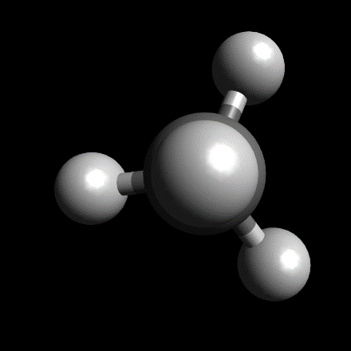 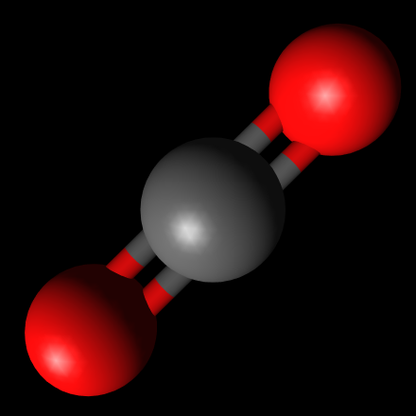

**Figure 2.1 & 2.2: CH4 and CO2 molecules created using Avogadro**

Open-source MD Package, LAMMPS (<https://www.lammps.org/>) was used for simulations. Open-source molecule builder and visualiser Avogadro (<https://avogadro.cc/>) and packing configurator Packmol (<https://m3g.github.io/packmol/>) were used for replicating molecules. Finally, open-source modelling and visualization software VMD (<https://www.ks.uiuc.edu/Research/vmd/>) was used for data visualization and analysis.

### **2.1.2 Simulation Conditions and Interaction Potentials**

Initial CH4 and CO2 molecules were created using Avogadro after which they were replicated using Packmol to create the individual systems (refer to Appendix A). The CO2 – CH4 binary gas mixture was created by defining a three-dimensional simulation box of dimensions 50 Å x 50 Å x 50 Å with periodic boundary conditions. The systems created were then converted to LAMMPS DATA format for compatibility with the LAMMPS MD package (refer to Appendix B). Multiple DATA files for both the CH4 and CO2 systems were generated with varying number of molecules, and thus varying concentrations. Each combination was then subjected to 5 sets of NPT simulations, each with 2 separate simulations of their own (refer to Appendix C):

1. For the first set of simulations, the first simulation was performed at PT conditions of 5000 atm and 1000 K for 50000 time steps, after which a NVE ensemble (microcanonical ensemble or NVE ensemble is a statistical ensemble that maintains constant number of particles (N), constant volume (V) and constant energy of the system (E)) run of 10000 time steps was used to check for equilibrium. Another simulation was then performed at PT conditions of 1000 atm and 1000 K for 50000 time steps, followed by a similar NVE equilibrium check (refer to Appendix C).
2. The second set of simulations was run similarly, but the temperature for both simulations was changed to 900 K.
3. In the third set of simulations, the temperature was set to 800 K for both simulations.
4. The temperature was further reduced to 700 K for the fourth set of simulations.
5. Finally, for the fifth set of simulations, the temperature was set to 600 K.

The time step for all simulations was chosen as 1 femtosecond (fs). Inter-atomic simulations were simulated using OPLS-AA (Optimized Potentials for Liquid Simulations All Atom) by Jorgensen se al. The functional form of the OPLS force field (Jorgensen et. al, 1996) is as follows (Eq 2.1 to 2.5):

$E\left(r^{N}\right)=E_{bonds}+E_{angles}+E_{dihedrals}+E_{nonbonded}$ (2.1)

$E_{bonds}= \sum_{bonds}{K_{r} {\left(r-r_{0}\right)}^{2}}$ (2.2)

$E_{angles}= \sum_{angles}{k_{θ} {\left(θ- θ_{0}\right)}^{2}}$ (2.3)

$E_{dihedrals}= \sum_{dihedrals}{\left(\frac{V_{1}}{2} \left[1+\cos\left(ϕ- ϕ_{1}\right)\right]+ \frac{V_{2}}{2} \left[1-\cos\left(2ϕ- ϕ_{2}\right)\right]+ \frac{V_{3}}{2} \left[1+\cos\left(3ϕ- ϕ_{3}\right)\right]+ \frac{V_{4}}{2} \left[1-\cos\left(4ϕ- ϕ_{4}\right)\right]\right)}$ (2.4)

$E_{nonbonded}= \sum_{i > j}{f_{ij} \left(\frac{A_{ij}}{r_{ij}^{12}}- \frac{C_{ij}}{r_{ij}^{6}}+ \frac{q_{i}q_{j}e^{2}}{4πϵ_{0}r_{ij}}\right)}$ (2.5)

With the combining rules $A_{ij}= \sqrt{A_{ii}A_{jj}}$ and $C_{ij}= \sqrt{C_{ii}C_{jj}}$

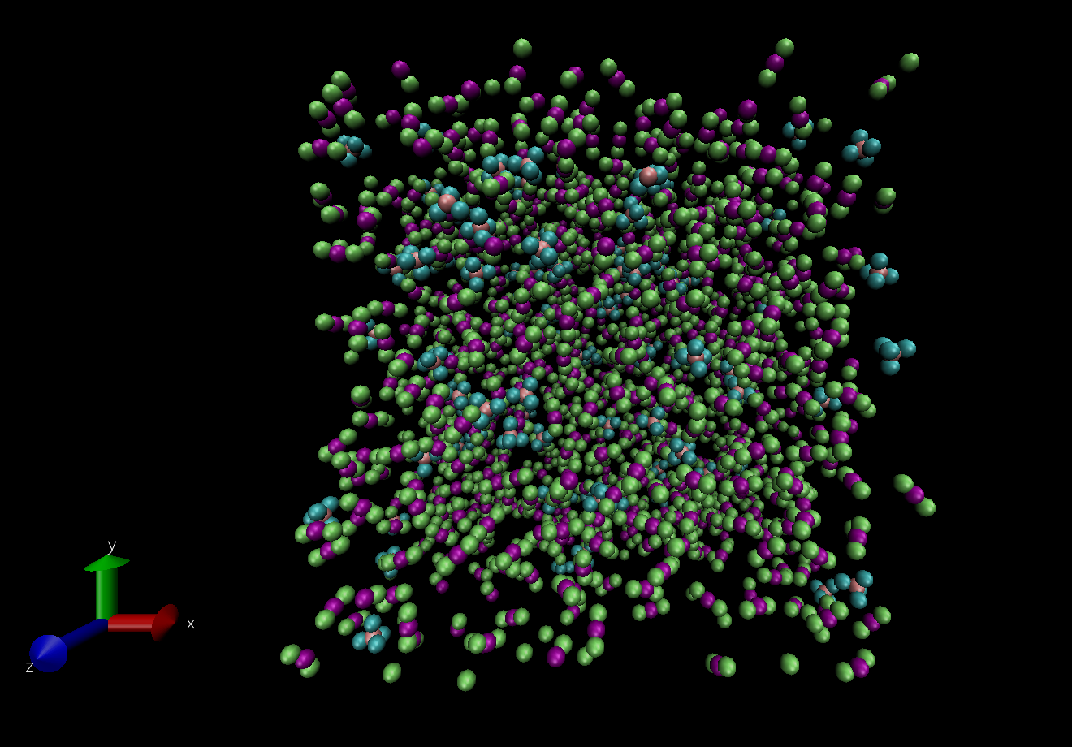

**Figure 2.1: Unequilibrated CO2 – CH4 mixture  
(XCH4 = 0.9; Pink – sp3 Carbon, Cyan – Hydrogen, Purple – sp Carbon, Green – Oxygen)**

The Lennard-Jones potential was used to determine short-range inter-atomic forces between the different pairs of atoms. The PPPM method (the PPPM method or P3M method uses a particle-particle particle-mesh solver (Hockney) which maps atom charge to a 3D mesh, uses 3D FFTs (Fast Fourier Transform algorithm) to solve Poisson’s equation on the mesh, then interpolates electric fields on the mesh points back to the atoms) was used to evaluate long-range coulombic interactions which take place due to the presence of partial charges on the molecules. The typical form of a Lennard-Jones Potential field (along with coulombic interactions) is as follows (Eq 2.6 to Eq 2.8):

$U_{ij}=4ϵ_{ij} \left[{\left(\frac{σ_{ij}}{r_{ij}}\right)}^{12}-{\left(\frac{σ_{ij}}{r_{ij}}\right)}^{6}\right]+ \frac{q_{i}q_{j}}{r_{ij}}$ (2.6)

$σ_{ij}= \frac{σ_{i}+ σ_{j}}{2}$ (2.7)

$ϵ_{ij}= \sqrt{ϵ_{i}ϵ_{j}}$ (2.8)

The interaction parameters for the potential for the OPLS-AA model for CH4 and CO2 are as follows (Table 2.1):

**Table 2.1: Parameters for OPLS-AA model of CO2 and CH4**

|  |  |  |  |
| --- | --- | --- | --- |
| **Species** | $σ_{i}$**(in Å)** | $ϵ_{i}$**(in kcal/mol)** | $$q_{i}/e$$ |
| C (sp3) | 3.581179283 | 0.066301549 | -0.52 |
| H | 2.373408142 | 0.028293678 | 0.13 |
| C (sp) | 2.811442217 | 0.245018224 | 0.752 |
| O | 2.625854035 | 0.412295446 | -0.376 |

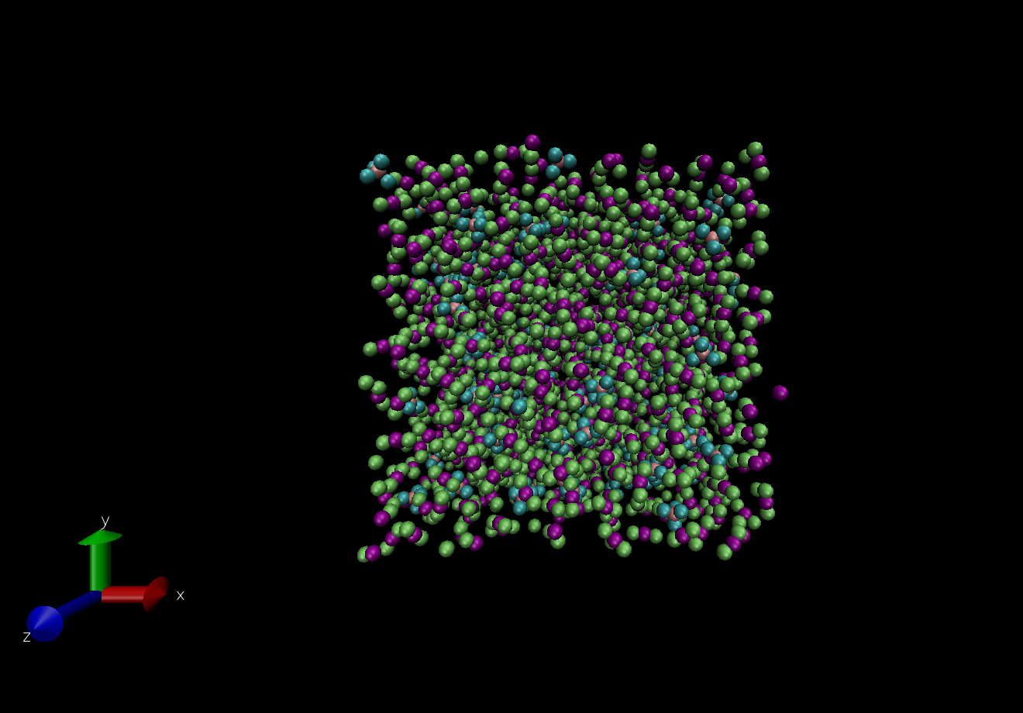

**Figure 2.2: Equilibrated CO2 – CH4 mixture  
(XCH4 = 0.9; Pink – sp3 Carbon, Cyan – Hydrogen, Purple – sp Carbon, Green – Oxygen)**

## **2.2 Data Analysis**

**Radial Distribution Function (RDF)**: In statistical mechanics, the radial distribution function (or pair correlation function) g(r) in a system of particles (atoms, molecules, colloids, etc.) describes how density varies as a function of distance from a reference particle. It is calculated by fixing a reference particle and a cut-off radius from the reference particles, after which the number of particles within spherical shells around the reference particle is counted. After accounting for all particle pairs, the data is binned into a histogram and normalised with respect to an ideal gas. This is illustrated as (Eq. 2.9 to 2.10 and Fig. 2.3):

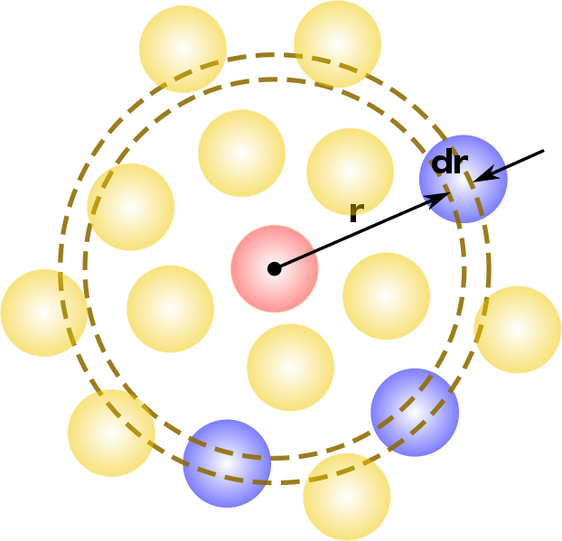

**Figure 2.3: Calculation of RDF g(r)**

$n\left(r\right)= \frac{1}{N}(\sum_{i=i}^{N}{\sum_{j ≠1}^{N}{δ |r-r_{ij}|}})$ (2.9)

Where 𝛿(r) is the Kronecker Delta Function which counts the number of particles at rij from the reference atom as shown in figure. RDF g(r) is calculated from n(r) as (Eq. 2.10):

$g\left(r\right)= \frac{n(r)}{ρ(4πr^{2}dr)}$ (2.10)

Where ρ is the number density of the system and 4πr2dr is the volume of a shell of radius dr at a distance r from the reference particle. In this work, the RDFs were generated by analyzing the trajectories of the particles using VMD.

**Density Calculation**: The system’s density was calculated using the data obtained at equilibrium from the NPT runs. The values obtained were compared against expected values at specified PT conditions to validate the simulated models. The formulas used for the same are as follows (Eq. 2.11 to Eq. 2.15):

$desnity\left(ρ\right)= \frac{Mass of particles (atoms) in the system}{Volume of simulation box at equilibrium}$ (2.11)

Expected density values were calculated using the Redlich-Kwong equation of state (Bakker, 1999) which is given by:

$P= \frac{RT}{v-b}- \frac{a}{v(v+b)\sqrt{T}}$ (2.12)

Where P, T and v are pressure, temperature and molar volume respectively; R is the gas constant and a and b are constants which represent attractive molecular forces and molecular size respectively.

These constants can be calculated for the require PT conditions as:

$a_{CH4}=3.1244 x {10}^{6}-2.4 x{10}^{3}T$ (2.13)

$a_{CO2}=73.03 x {10}^{6}-71400T+21.57T^{2}$ (2.14)

$a_{CH4-CO2}= \sqrt{a_{CH4}a_{CO2}}$ (2.15)

$b_{CH4}=29.8$

$b_{CO2}=29.7$

All formulas and data used for calculations were converted to SI units before application.

# **Chapter III: Results**

## **3.1 Findings**

The simulated model was validated by comparing simulated density values against expected density values at PT conditions and checking the RDF to ensure the system was at equilibrium.

**Table 3.1: Comparison of simulated and expected density values**

|  |  |  |  |  |  |  |
| --- | --- | --- | --- | --- | --- | --- |
| **XCH4** | **XCO2** | **P (in atm)** | **T (in K)** | **V (in Å3)** | **ρsim (in g/cc)** | **ρexp (in g/cc)** |
| 0.1 | 0.9 | 5000 | 1000 | 57000 | 1.20065 | 1.07337 |
| 0.1 | 0.9 | 1000 | 1000 | 86300 | 0.79301 | 1.07027 |
| 0.1 | 0.9 | 5000 | 900 | 52700 | 1.29862 | 1.07317 |
| 0.1 | 0.9 | 1000 | 900 | 74700 | 0.91616 | 1.06928 |
| 0.1 | 0.9 | 5000 | 800 | 50900 | 1.34454 | 1.07245 |
| 0.1 | 0.9 | 1000 | 800 | 64700 | 1.05776 | 1.06764 |
| 0.1 | 0.9 | 5000 | 700 | 48000 | 1.42577 | 1.07219 |
| 0.1 | 0.9 | 1000 | 700 | 58000 | 1.17995 | 1.06545 |
| 0.1 | 0.9 | 5000 | 600 | 45000 | 1.52082 | 1.07198 |
| 0.1 | 0.9 | 1000 | 600 | 51600 | 1.32630 | 1.06332 |
| 0.3 | 0.7 | 5000 | 1000 | 58200 | 1.01630 | 0.92721 |
| 0.3 | 0.7 | 1000 | 1000 | 96600 | 0.61231 | 0.92356 |
| 0.3 | 0.7 | 5000 | 900 | 55000 | 1.07543 | 0.92650 |
| 0.3 | 0.7 | 1000 | 900 | 82800 | 0.71436 | 0.92206 |
| 0.3 | 0.7 | 5000 | 800 | 51600 | 1.14629 | 0.92649 |
| 0.3 | 0.7 | 1000 | 800 | 73400 | 0.80584 | 0.92003 |
| 0.3 | 0.7 | 5000 | 700 | 49600 | 1.19252 | 0.92625 |
| 0.3 | 0.7 | 1000 | 700 | 64200 | 0.92132 | 0.91849 |
| 0.3 | 0.7 | 5000 | 600 | 47400 | 1.24786 | 0.92559 |
| 0.3 | 0.7 | 1000 | 600 | 59400 | 0.99577 | 0.91629 |
| 0.5 | 0.5 | 5000 | 1000 | 60000 | 0.83101 | 0.78089 |
| 0.5 | 0.5 | 1000 | 1000 | 114500 | 0.43546 | 0.77787 |
| 0.5 | 0.5 | 5000 | 900 | 57700 | 0.86413 | 0.78069 |
| 0.5 | 0.5 | 1000 | 900 | 97000 | 0.51403 | 0.77641 |
| 0.5 | 0.5 | 5000 | 800 | 55500 | 0.89839 | 0.78047 |
| 0.5 | 0.5 | 1000 | 800 | 87500 | 0.56983 | 0.77499 |
| 0.5 | 0.5 | 5000 | 700 | 51400 | 0.97005 | 0.77988 |
| 0.5 | 0.5 | 1000 | 700 | 75300 | 0.66216 | 0.77316 |
| 0.5 | 0.5 | 5000 | 600 | 49100 | 1.01549 | 0.77972 |
| 0.5 | 0.5 | 1000 | 600 | 64400 | 0.77423 | 0.77132 |
| 0.7 | 0.3 | 5000 | 1000 | 69000 | 0.58800 | 0.63521 |
| 0.7 | 0.3 | 1000 | 1000 | 124000 | 0.32720 | 0.63272 |
| 0.7 | 0.3 | 5000 | 900 | 63000 | 0.64400 | 0.63513 |
| 0.7 | 0.3 | 1000 | 900 | 118700 | 0.34180 | 0.63200 |
| 0.7 | 0.3 | 5000 | 800 | 59900 | 0.67733 | 0.63481 |
| 0.7 | 0.3 | 1000 | 800 | 104600 | 0.38788 | 0.63089 |
| 0.7 | 0.3 | 5000 | 700 | 58100 | 0.69832 | 0.63466 |
| 0.7 | 0.3 | 1000 | 700 | 92000 | 0.44100 | 0.62927 |
| 0.7 | 0.3 | 5000 | 600 | 54700 | 0.74172 | 0.63426 |
| 0.7 | 0.3 | 1000 | 600 | 83400 | 0.48648 | 0.62774 |
| 0.9 | 0.1 | 5000 | 1000 | 73600 | 0.42505 | 0.48984 |
| 0.9 | 0.1 | 1000 | 1000 | 152300 | 0.20541 | 0.48849 |
| 0.9 | 0.1 | 5000 | 900 | 71300 | 0.43877 | 0.48964 |
| 0.9 | 0.1 | 1000 | 900 | 139900 | 0.22362 | 0.48781 |
| 0.9 | 0.1 | 5000 | 800 | 67200 | 0.46554 | 0.48950 |
| 0.9 | 0.1 | 1000 | 800 | 127600 | 0.24517 | 0.48714 |
| 0.9 | 0.1 | 5000 | 700 | 62900 | 0.49736 | 0.48930 |
| 0.9 | 0.1 | 1000 | 700 | 115600 | 0.27062 | 0.48635 |
| 0.9 | 0.1 | 5000 | 600 | 60700 | 0.51539 | 0.48904 |
| 0.9 | 0.1 | 1000 | 600 | 99900 | 0.31315 | 0.48542 |

The RDFs generated for different pairs of atoms are as follows (Fig. 3.1 to Fig 3.10):

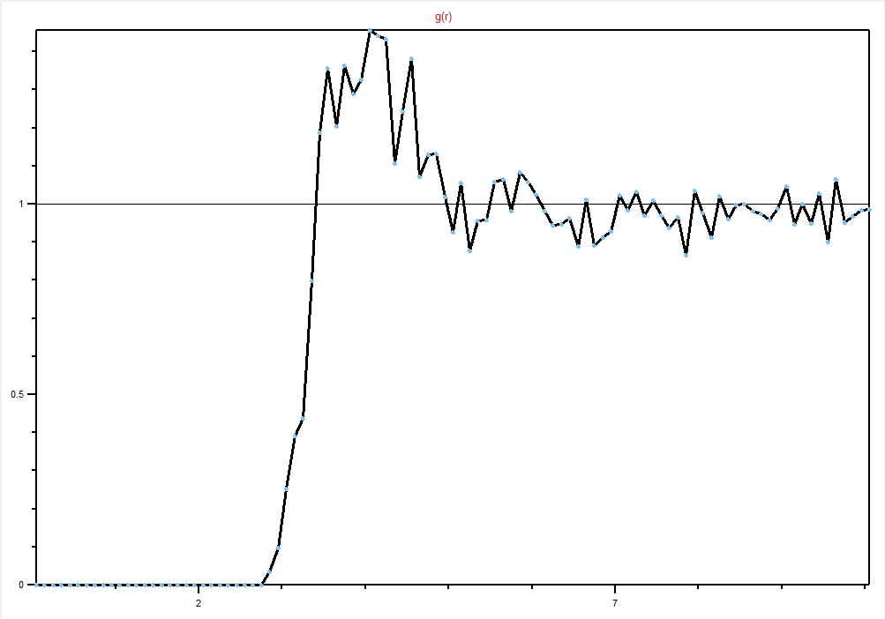

**Figure 3.1: C (sp3) – C (sp3) RDF (P = 5000 atm, T = 1000 K, XCH4 = 0.1)**

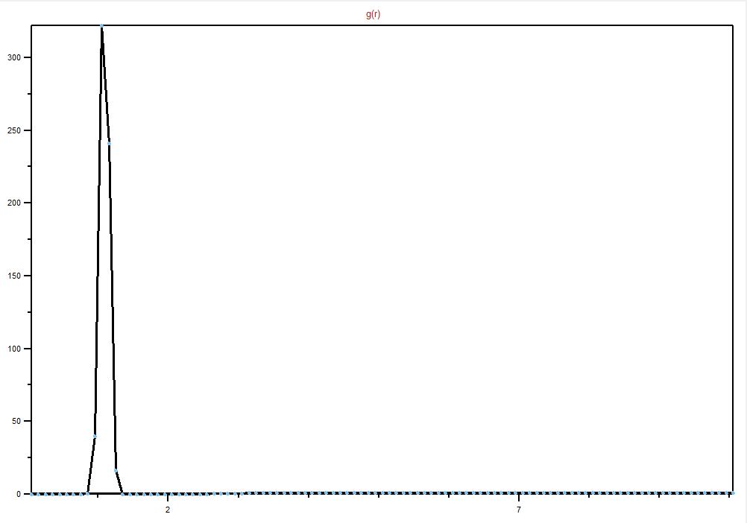

**Figure 3.2:** **C (sp3) – H RDF (P = 5000 atm, T = 1000 K, XCH4 = 0.1)**

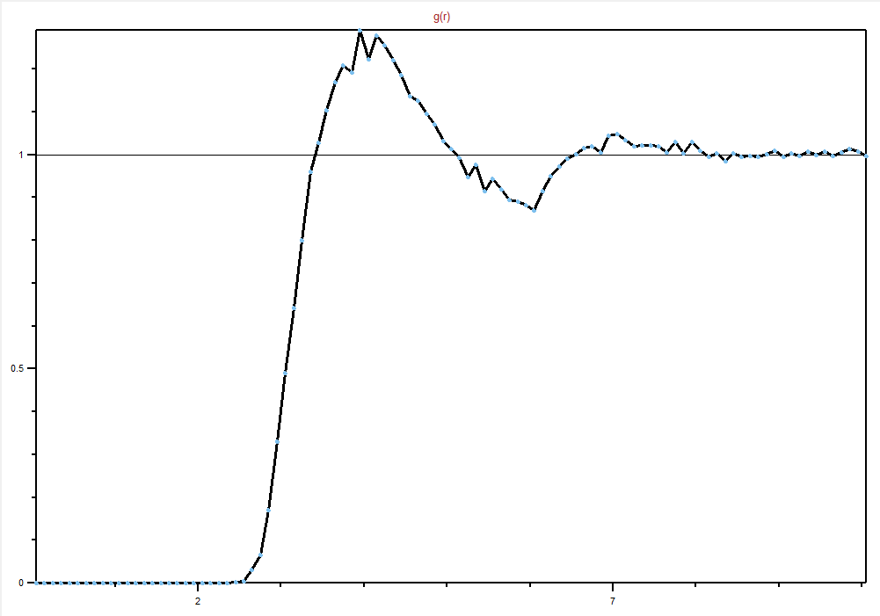

**Figure 3.3: C (sp3) – C (sp) RDF (P = 5000 atm, T = 1000 K, XCH4 = 0.1)**

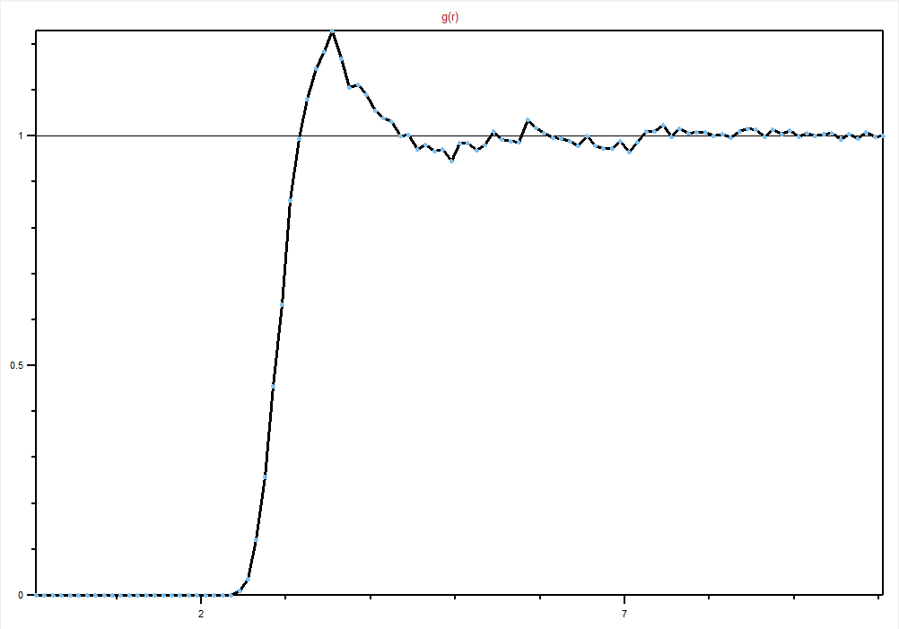

**Figure 3.4: C (sp3) – O RDF (P = 5000 atm, T = 1000 K, XCH4 = 0.1)**

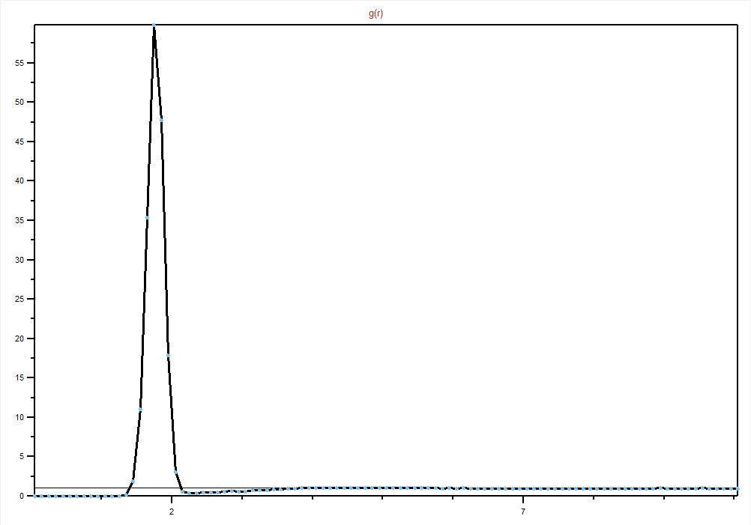

**Figure 3.5: H – H RDF (P = 5000 atm, T = 1000 K, XCH4 = 0.1)**

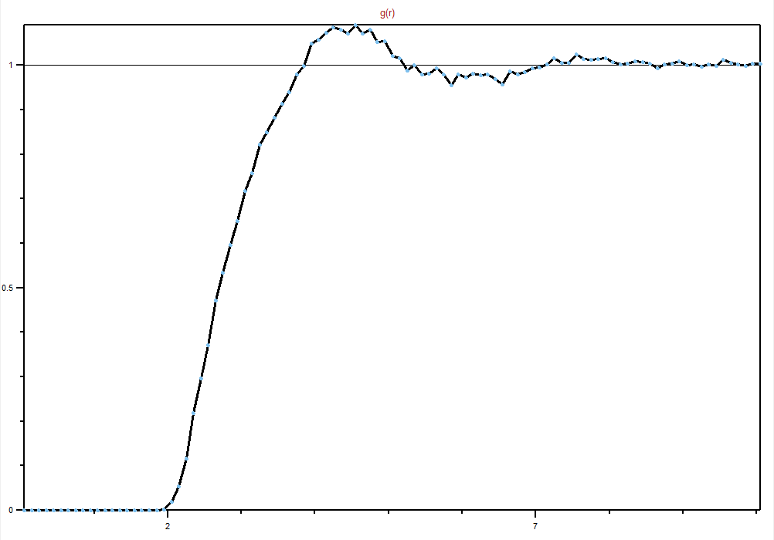

**Figure 3.6: H – C (sp) RDF (P = 5000 atm, T = 1000 K, XCH4 = 0.1)**

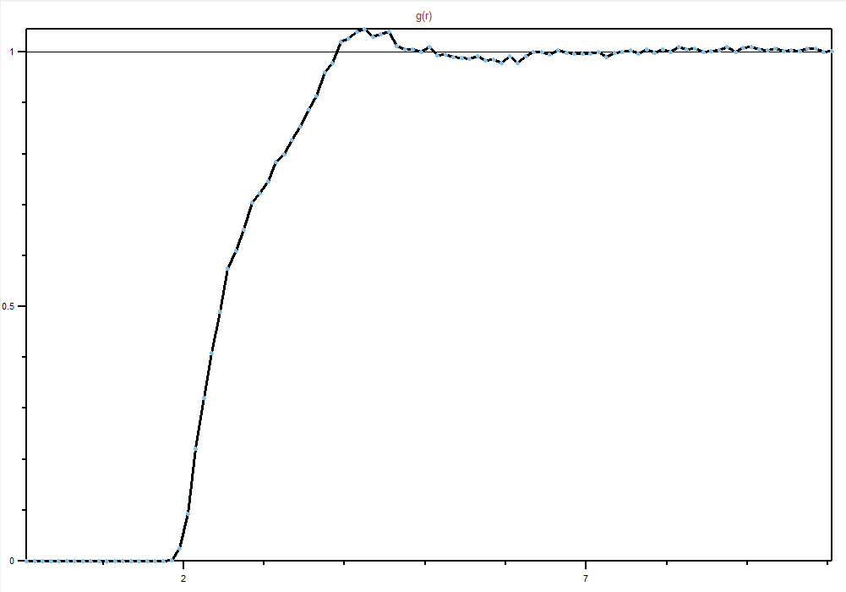

**Figure 3.7: H – O RDF (P = 5000 atm, T = 1000 K, XCH4 = 0.1)**

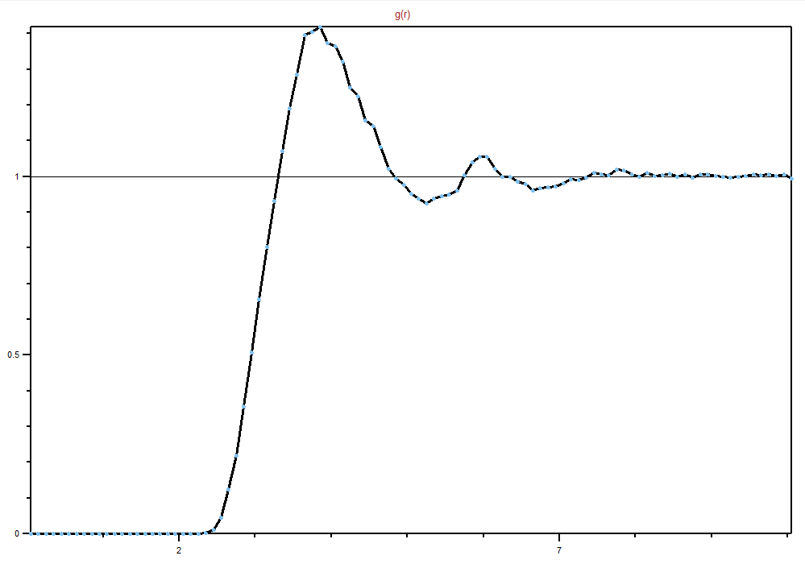

**Figure 3.8: C (sp) – C (sp) RDF (P = 5000 atm, T = 1000 K, XCH4 = 0.1)**

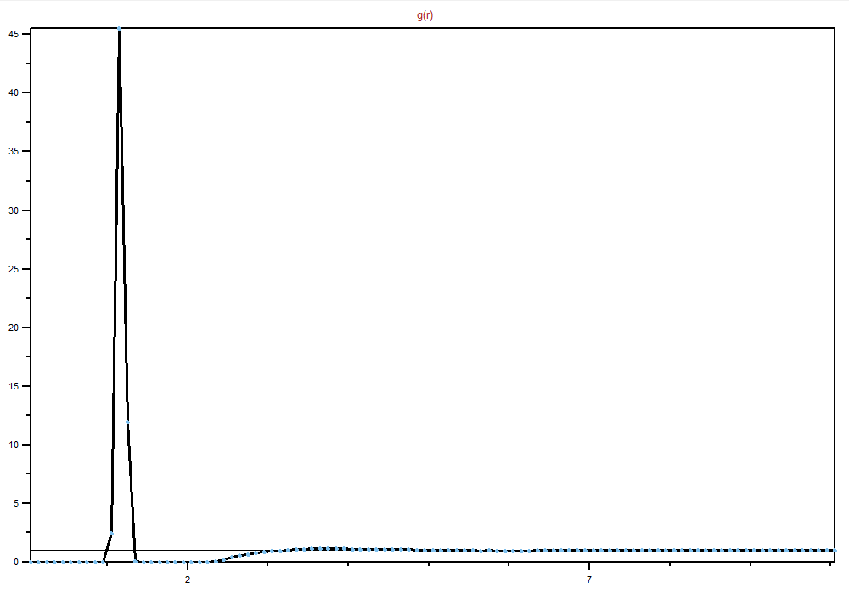

**Figure 3.9: C (sp) – O RDF (P = 5000 atm, T = 1000 K, XCH4 = 0.1)**

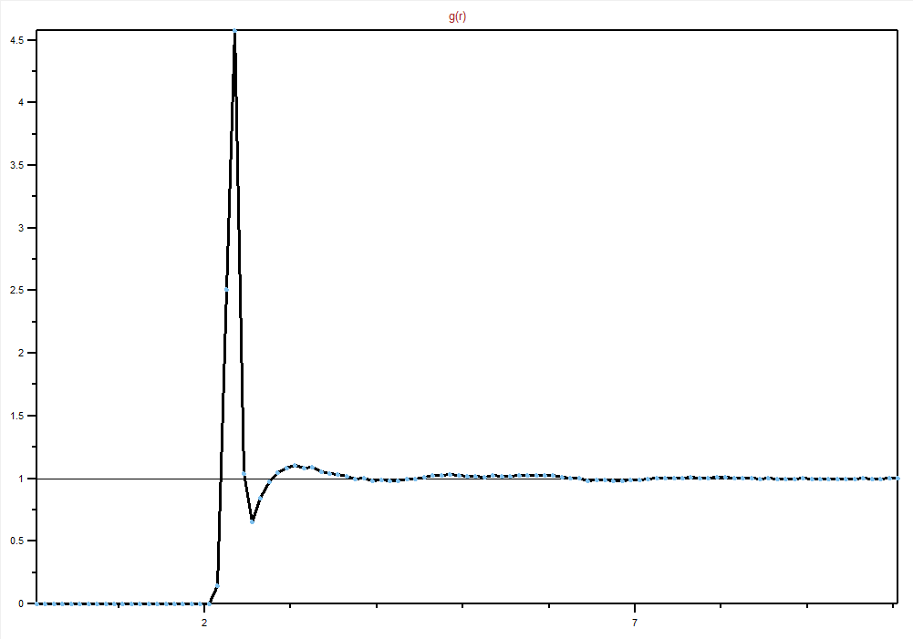

**Figure 3.10: O – O RDF (P = 5000 atm, T = 1000 K, XCH4 = 0.1)**

Here we can see the binary gas mixture’s volume decreasing when the system is subjected to high PT conditions of 5000 atm and 1000K (Fig. 3.11 to Fig. 3.14).

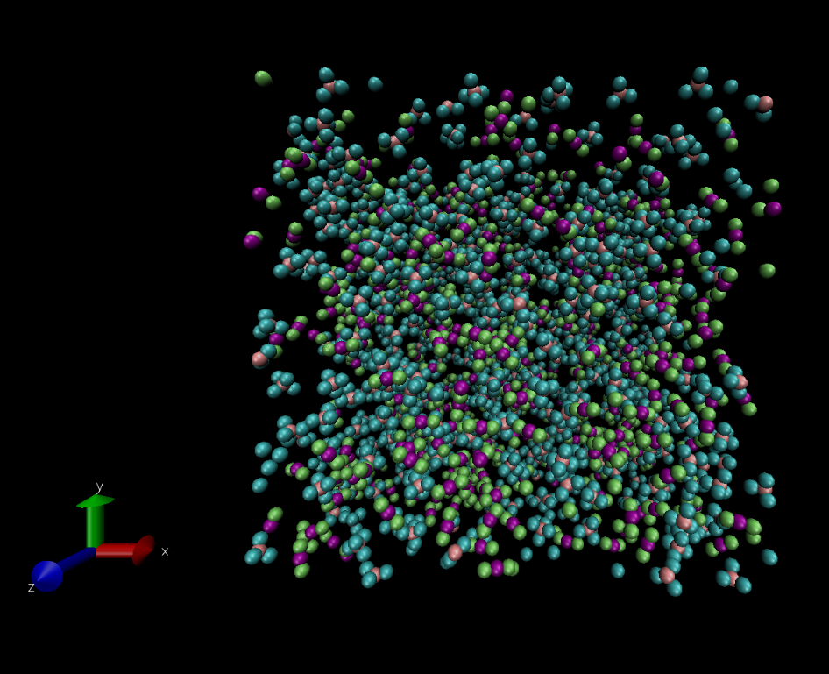

**Figure 3.11: Simulation model after 0 time steps (P = 5000 atm, T = 1000 K, XCH4 = 0.5)**

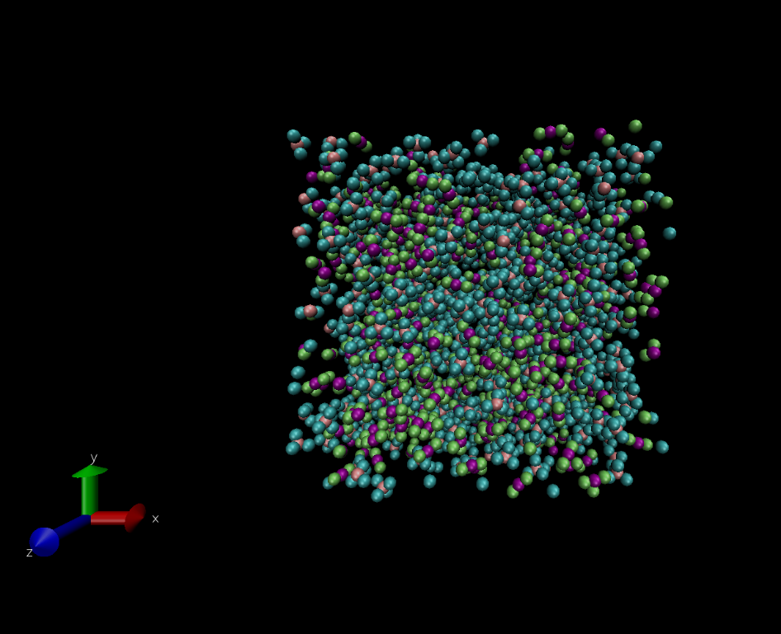

**Figure 3.12: Simulation model after 10000 time steps (P = 5000 atm, T = 1000 K, XCH4 = 0.5)**

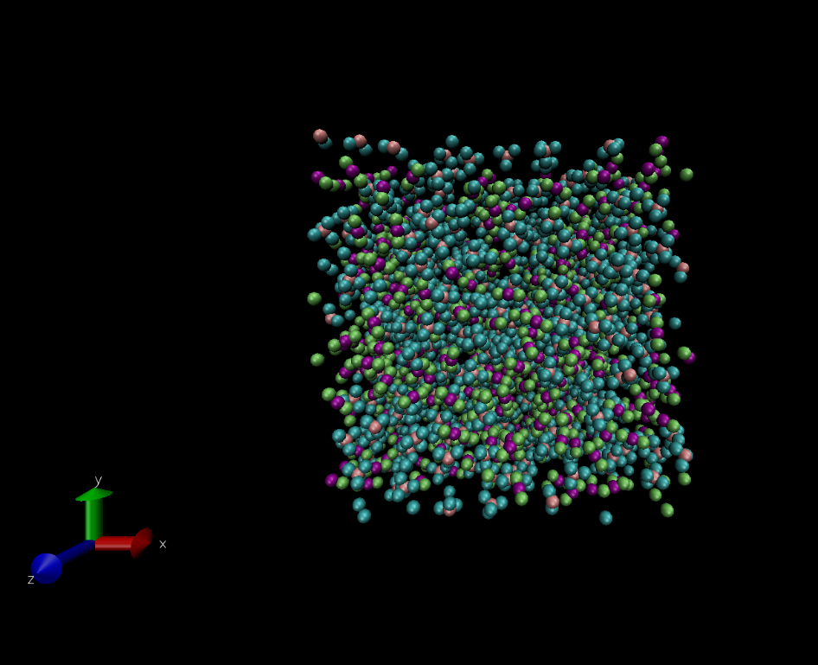

**Figure 3.13: Simulation model after 20000 time steps (P = 5000 atm, T = 1000 K, XCH4 = 0.5)**

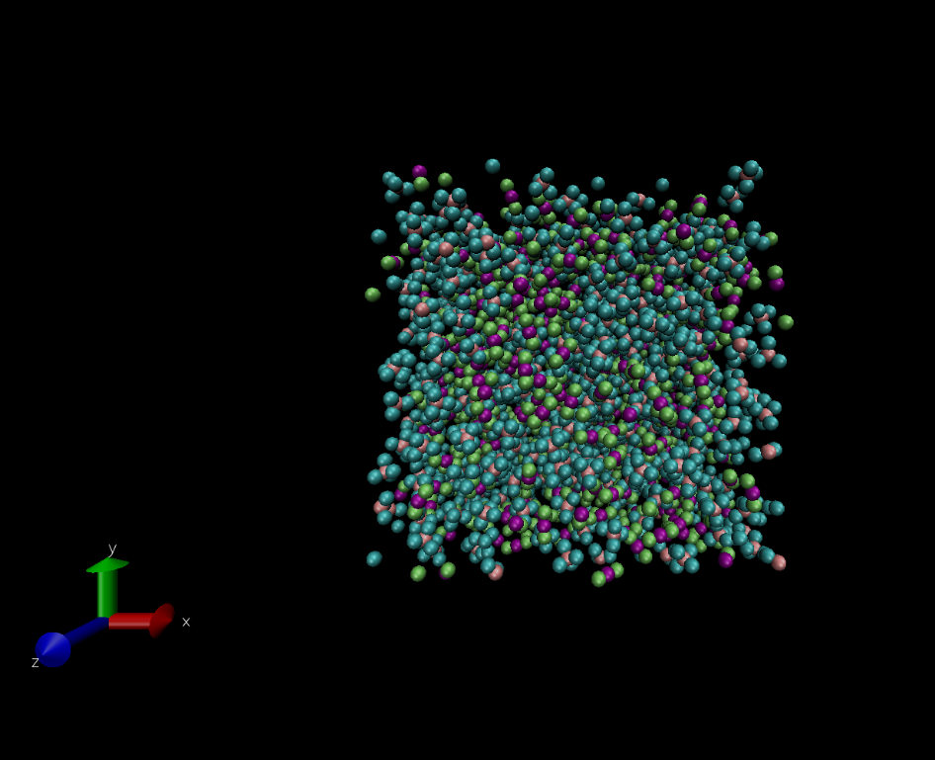

**Figure 3.14: Simulation model after 40000 timesteps (P = 5000 atm, T = 1000 K, XCH4 = 0.5)**

Here we can see the binary gas mixture’s (XCH4 = 0.5) volume increasing when the system is subjected to a lower PT condition of 1000 atm and 1000 K (Fig. 3.15 to Fig. 3.18).

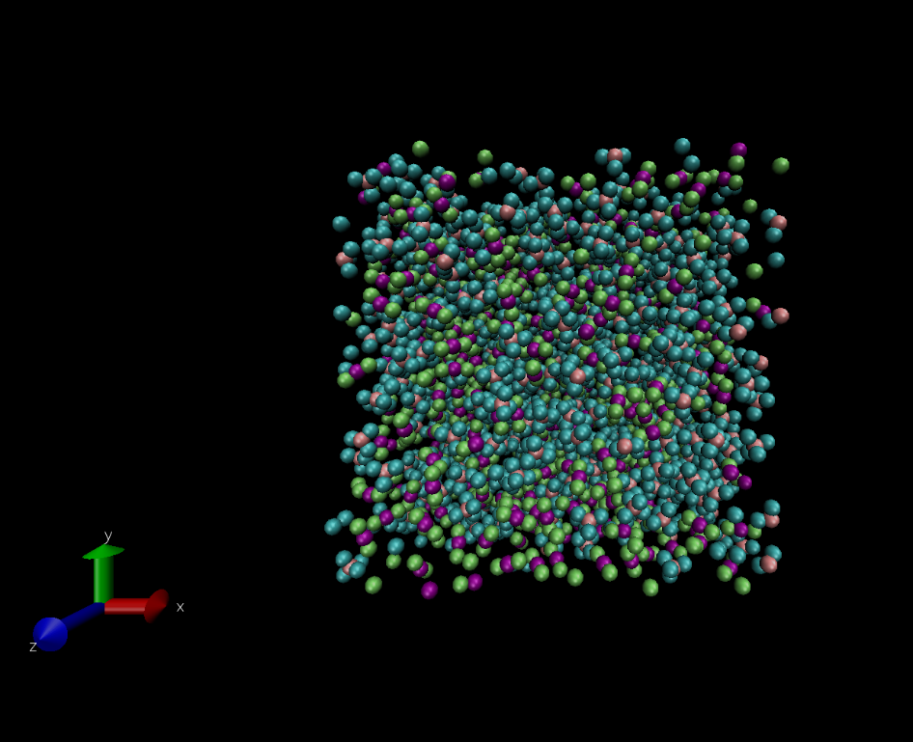

**Figure 3.15: Simulation model after 0 time steps (P = 1000 atm, T = 1000 K, XCH4 = 0.5)**

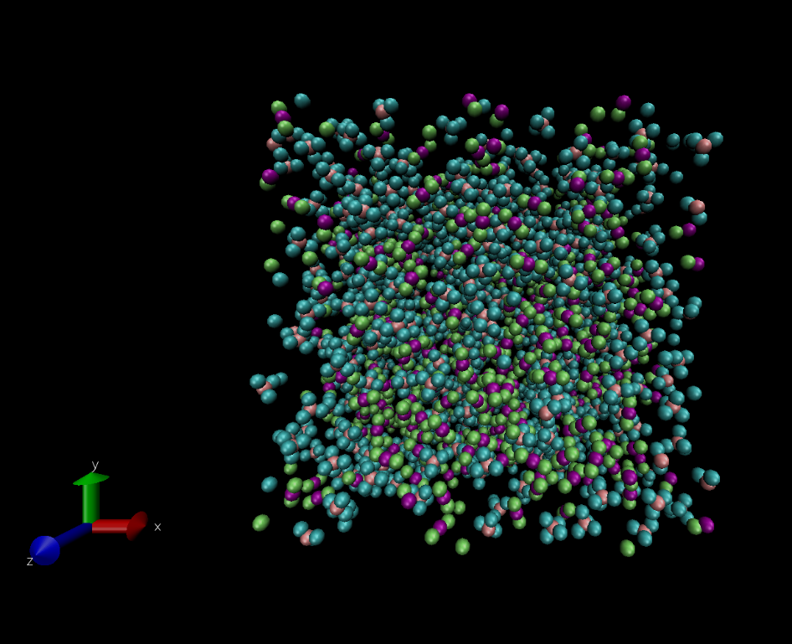

**Figure 3.16: Simulation model after 10000 time steps (P = 1000 atm, T = 1000 K, XCH4 = 0.5)**

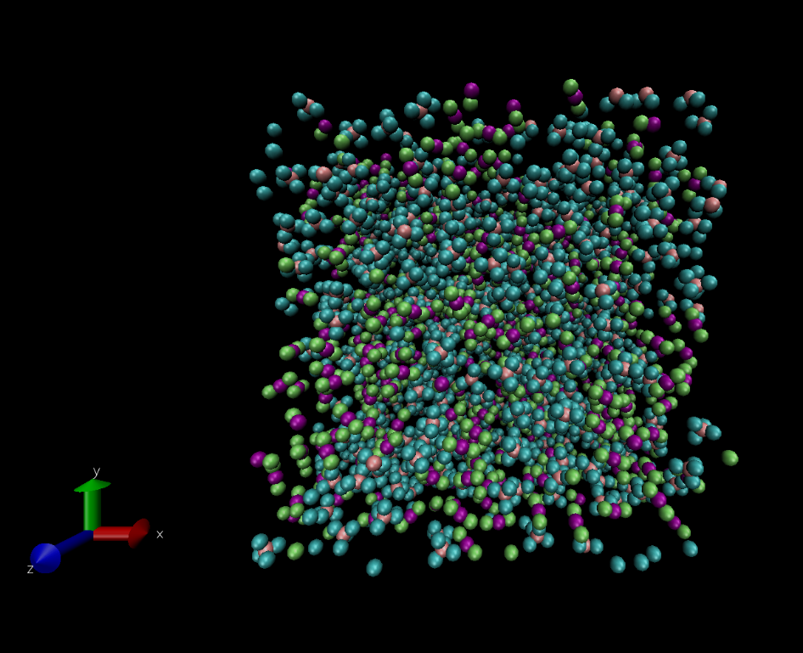

**Figure 3.17: Simulation model after 20000 time steps (P = 1000 atm, T = 1000 K, XCH4 = 0.5)**

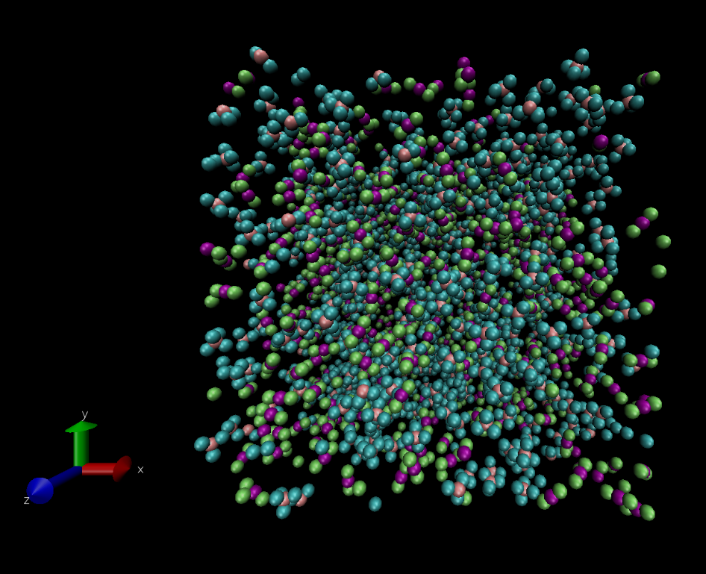

**Figure 3.18: Simulation model after 40000 time steps (P = 1000 atm, T = 1000 K, XCH4 = 0.5)**

## **3.2 Summary**

1. Some of the simulated density values match with the expected density values. Some values are off by a small margin, and there are also some values which are significantly different from the calculated values.
2. The RDFs of all the pairs of atoms even out (stop fluctuating) and assume the correct value of g(r) = 1 (for large distances), which shows that the system attains equilibrium.
3. We can see an apparent effect of the increase and decrease in simulation PT conditions on the system’s volume (simulation box).
4. CH4 and CO2 molecules don’t show any changes to their random trajectories, as seen from the simulations’ visualisation.

# **Chapter IV: Discussion**

## **4.1 Conclusions**

CH4 and CO2 do not show any miscibility at high PT conditions; the movement of molecules of both gases are similar at the 2 different PT conditions used in each set of simulations. The molecules of both gases do not show any layering or clustering, i.e., they are randomly distributed in space and do not seem to influence each other. Some of the simulations are successfully equilibrated, but the other simulations differ from the expected outcome.

## **4.2 Discussion**

Observing the trajectories of CH4 and CO2 molecules for several different concentration values and PT conditions, we can see that while some intermolecular forces may act within the system, they don’t affect the overall motion (randomness of the system). There is no preferential clustering of molecules within the bounds of the system, i.e., the molecules are evenly spaced out within the simulation box. We can say that without using reactive parameters for accounting for changes within the system, both gases CH4 and CO2 are immiscible even under high PT conditions. We can see that some data closely matches the expected simulation results, while some others are off by a margin. This may be due to the difference in initial configurations of the system DATA files that have been used. Some other factors which may account for these discrepancies may be tied to the assumptions we made while conducting this study. Finally, a larger simulation box may help with more accurate results for the last group of simulations, i.e., XCH4 = 0.1

## **4.3 Suggestions for Future Research**

The current study is only for a simple interaction between CH4 and CO2. To improve upon the results of this study, further research can be done making the use of reactive force field (ReaxFF). This will help account for the formation of precipitate or any other substance in the system. Inclusion of external forces along the boundary of the simulation box may lead to results which more accurately reveal the interaction of CO2 and CH4 in nature (e.g., subsurface).

# **References**

Bakker, R.J. (1999) Adaptation of the Bowers and Helgeson (1983) equation of state to the H2O-CO2-CH4-N2-NaCl system. *Chemical Geology 1999, 154, 225–236*

Jorgensen, W.L., Maxwell, D.S., and Tirado-Rives, J. (1996) Development and Testing of the OPLS All-Atom Force Field on Conformational Energetics and Properties of Organic Liquids. *J. Am. Chem. Soc. 1996, 118, 45, 11225–11236*

Kiehl, J.T., and Trenberth, K.E. (1997) Earth’s Annual Global Mean Budget. *Bulletin of the American Meteorological Society 1997,78, 2, 197-208*

# **Appendices**

## **Appendix A – Packmol Code**

**Code used to generate atoms for XCH4 = 0.5 mixture**

tolerance 2.0

filetype pdb

output CH4_05.pdb

structure CH4.pdb  
 number 500  
 inside box 0. 0. 0. 40. 40. 40.

end structure

**Code used to generate atoms for XCO2 = 0.5 mixture**

tolerance 2.0

filetype pdb

output CO2_05.pdb

structure CO2.pdb  
 number 500  
 inside box 0. 0. 0. 40. 40. 40.

end structure

## **Appendix B – LAMMPS Molecular DATA**

**LAMMPS DATA file for CH4 system**

LAMMPS data file. CGCMM style. atom_style full generated by VMD/TopoTools v1.8 on Fri Apr 28 19:48:40 +0530 2023

2500 atoms

2000 bonds

3000 angles

0 dihedrals

0 impropers

2 atom types

1 bond types

1 angle types

0 dihedral types

0 improper types

-5.000000 45.000000 xlo xhi

-5.000000 45.000000 ylo yhi

-5.000000 45.000000 zlo zhi

Masses

1 12.010700 # C

2 1.007940 # H

Atoms # full

1 1 1 -0.520000 26.841999 17.820999 22.805000 # C UNL

2 1 2 0.130000 27.594999 17.080000 23.082001 # H UNL

3 1 2 0.130000 27.108000 18.789000 23.233999 # H UNL

4 1 2 0.130000 25.867001 17.509001 23.186001 # H UNL

…

…

…

2497 500 2 0.130000 27.540001 4.855000 12.934000 # H UNL

2498 500 2 0.130000 27.486000 6.284000 14.000000 # H UNL

2499 500 2 0.130000 26.983000 6.424000 12.295000 # H UNL

2500 500 2 0.130000 28.704000 6.186000 12.700000 # H UNL

Bonds

1 1 1 2

2 1 1 3

3 1 1 4

4 1 1 5

…

…

…

1997 1 2496 2497

1998 1 2496 2498

1999 1 2496 2499

2000 1 2496 2500

Angles

1 1 2 1 3

2 1 2 1 4

3 1 2 1 5

4 1 3 1 4

…

…

…

2997 1 2497 2496 2500

2998 1 2498 2496 2499

2999 1 2498 2496 2500

3000 1 2499 2496 2500

Pair Coeffs

1 0.066301549 3.581179283 # C

2 0.028293678 2.373408142 # H

Bond Coeffs

1 349.274139579 1.09 # C-H

Angle Coeffs

1 47.481670729 109.5 # H-C-H

**LAMMPS DATA file for CO2 system**

LAMMPS data file. CGCMM style. atom_style full generated by VMD/TopoTools v1.8 on Fri Apr 28 20:25:30 +0530 2023

1500 atoms

1000 bonds

500 angles

0 dihedrals

0 impropers

2 atom types

1 bond types

1 angle types

0 dihedral types

0 improper types

-5.000000 45.000000 xlo xhi

-5.000000 45.000000 ylo yhi

-5.000000 45.000000 zlo zhi

Masses

1 12.010700 # C

2 15.999400 # O

Atoms # full

1 1 1 0.752000 26.846001 17.723000 22.618999 # C UNL

2 1 2 -0.376000 27.184999 17.763000 23.766001 # O UNL

3 1 2 -0.376000 26.507000 17.681999 21.471001 # O UNL

4 2 1 0.752000 17.857000 18.997000 18.264999 # C UNL

…

…

…

1497 499 2 -0.376000 6.329000 11.233000 12.548000 # O UNL

1498 500 1 0.752000 37.678001 23.889999 1.966000 # C UNL

1499 500 2 -0.376000 36.666000 24.261999 2.486000 # O UNL

1500 500 2 -0.376000 38.689999 23.518000 1.447000 # O UNL

Bonds

1 1 1 2

2 1 1 3

3 1 4 5

4 1 4 6

…

…

…

997 1 1495 1496

998 1 1495 1497

999 1 1498 1499

1000 1 1498 1500

Angles

1 1 2 1 3

2 1 5 4 6

3 1 8 7 9

4 1 11 10 12

…

…

…

497 1 1490 1489 1491

498 1 1493 1492 1494

499 1 1496 1495 1497

500 1 1499 1498 1500

Pair Coeffs

1 0.245018224 2.811442217 # C

2 0.412295446 2.625854035 # O

Bond Coeffs

1 1063.575525812 1.17 # C-O

Angle Coeffs

1 48.240031165 180 # O-C-O

## **Appendix C – LAMMPS Simulation Code**

**Simulation Code for XCH4 = 0.1 and XCO2 = 0.9**

# --------------------- Initialization

units real

dimension 3

atom_style full

boundary p p p

# --------------------- System definition

pair_style lj/cut/coul/long 12.0 6.0

bond_style harmonic

angle_style harmonic

*# Extra parameters defined to add CO2 data to initial system configuration*

read_data CH4_01.data extra/atom/types 2 extra/bond/types 1 extra/angle/types 1

read_data CO2_09.data add append offset 2 1 1 0 0

*# PPPM style is used due to coul/long pair style*

kspace_style pppm 1.0e-2

pair_modify mix geometric shift yes

# --------------------- Simulation settings

neighbor 4.0 bin

neigh_modify delay 5 check yes

# --------------------- Equilibration #1

velocity all create 1000.0 69420 dist gaussian mom yes rot yes

timestep 1.0

thermo 1000

*# Limit imposed to NVE runs to prevent the system from exploding due to initial irregularities*

fix eq1 all nve/limit 0.1

run 30000

unfix eq1

reset_timestep 0

# --------------------- Simulation #1 (T = 1000 K, P = 5000 atm)

*# Initital PT conditions are 1700 atm and 1850 K (from NVE run)*

fix sim1 all npt temp 1850 1000 100 iso 1700 5000 1000

dump dat1 all atom 500 hcg_1.lammpstrj

run 50000

undump dat1

unfix sim1

write_data hcg_1mix.data

reset_timestep 0

# --------------------- Equilibration #2

fix eq2 all nve

run 10000

unfix eq2

reset_timestep 0

# --------------------- Simulation #2 (T = 1000 K, P = 1000 atm)

*# Initital PT conditions are 5850 atm and 1000 K (from NVE run)*

fix sim2 all npt temp 1000 1000 100 iso 5850 1000 1000

dump dat2 all atom 500 hcg_2.lammpstrj

run 50000

undump dat2

unfix sim2

write_data hcg_2mix.data

reset_timestep 0

# --------------------- Equilibration #3

fix eq3 all nve

run 10000

unfix eq3